Stage 3 Physics:
Motion and forces in electric and magnetic fields

Student Workbook
TEACHER’S GUIDE

Week | Content | Physics Content & Contexts 3A & 3B  Reference pages | Exploring Physics |  | Assessments
Week | Content | Physics Content & Contexts 3A & 3B  Reference pages | Possible  Problem Sets | Possible Experiments & Investigations | Assessments
3 | Motion and forces in electric and magnetic fields  - explain that point charges create radial electric fields  - describe, using diagrams, electric field distributions around simple combinations of charged points, spheres and plates  - describe, explain and use electric fields between parallel plates and within uniform conductors, to explain the forces on charged particles—this will include applying the relationships: 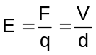 | Unit 2A & 2B text  Pg. 334-346 | Set 14: Charged Particles in Magnetic Fields
4-5 | - apply the concept of force on a charged particle moving through a magnetic field—this will include applying the relationships: 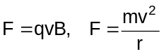  - describe the factors which affect the magnitude and direction of the force on a charged particle moving through a magnetic field | Pg. 347-364 |  | Expt: 14.1 | Task 3: Extended Investigation due  Task 5: Validation tests on Assignments, Problem sets and homework
6-7 | explain and apply the concepts of electric and magnetic field in sequence or in combination—this will include applying the relationships:  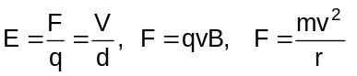 | Pg. 347-364 | Set 15: Charged Particles in Combined Electric and Magnetic Fields | Expt: 15.1 | Task 10: Test Motion and Forces in electric and magnetic fields
8-  10 | Review |  |  |  | Task 4 : Practical Examination 3B content
 | EXAMINATION |  |  |  | Task 12: Stage 3 Examination

Assessment outline: Stage 3 PHYSICS
Outcome 01: Investigating and Communicating in Physics; Outcome 02: Energy; Outcome 03: Forces and Fields

Assessment type | Assessment type weightings | Tasks | Content | Outcomes coverage |  |  | Weighting  %
 |  |  |  | 1 | 2 | 3 | 3A | 3B | Total
Experiments and investigations  (20-40%) | 21% | Task 1: Practical exam (3A) | Practical exam on 3A experiments and investigations |  |  |  | 5 |  | 5
Experiments and investigations  (20-40%) | 21% | Task 2: Research topic | Validation activity on student research (written report) |  |  |  |  | 3 | 3
Experiments and investigations  (20-40%) | 21% | Task 3: Extended Investigation | Extended investigation |  |  |  | 4 | 4 | 6
Experiments and investigations  (20-40%) | 21% | Task 4: Practical exam (3B) | Practical exam on 3B experiments and investigations |  |  |  |  | 5 | 7
Tests  and  Examinations  (60-80%) | 79% | Task 5:Validation tests on Assignments, Problem Sets and Homework | Accumulation of validation tests on Assignments, Problem Sets and homework |  |  |  | 2 | 2 | 4
Tests  and  Examinations  (60-80%) | 79% | Task 6: Test Projectile Motion | Test on projectile motion |  |  |  | 3 |  | 3
Tests  and  Examinations  (60-80%) | 79% | Task 7: Test Motion and forces in a gravitational field | Test on Motion and forces in gravitation al field |  |  |  | 4 |  | 4
Tests  and  Examinations  (60-80%) | 79% | Task 8: Test electricity and magnetism | Test on Electricity and Magnetism unit |  |  |  | 6 |  | 6
Tests  and  Examinations  (60-80%) | 79% | Task 9: Test Particles, waves and quanta | Test on Particles, waves and quanta unit |  |  |  |  | 6 | 6
Tests  and  Examinations  (60-80%) | 79% | Task 10: Test Motion and Forces in Electric and Magnetic Field | Test on Motion and Forces in Electric and Magnetic Field unit |  |  |  |  | 6 | 6
Tests  and  Examinations  (60-80%) | 79% | Task 11: Semester One Examination | Examination on 3A |  |  |  | 20 |  | 20
Tests  and  Examinations  (60-80%) | 79% | Task 12:Stage 3 Examination (includes 20% of 3A) | Examination on Stage 3 work |  |  |  | 5 | 25 | 30
 |  |  |  |  |  |  | 50 | 50 | 100

Outcome 1:
Explain that point charges create radial electric fields.

Radial Electric Fields

An electric field is defined as an area of influence around a charged object. Any charged particle within this electric field will experience a force on it. Unlike gravitational fields which can only attract, electric fields can both attract and repel.

If a point charge experiences a force then an electric field exists. Remember that force is a vector quantity and likewise, an electric field is a vector quantity.

We use field lines as a means of providing a picture of an electric field; however these lines do not actually exist, they are only a representation of the electric field. Line density indicates the strength of the field (and hence the force on the particle). The direction of the electric field is found by considering the direction a positively charged object would move if placed at that point in the field. All field lines you draw must have an arrow to show the direction of the field.

Your teacher will illustrate the following fields:
Field around a point charge where the point is (i) negative, and (ii) positive.
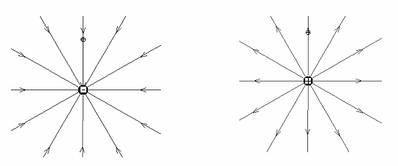

Outcome 2:
Describe, using diagrams, electric field distributions around simple combinations of charged points, spheres and plates.

Fields exist around combinations of charged objects and the resultant field is a a vector sum of the individual fields at any particular point.

Your teacher will help you determine the field around the following situations.
a. Field between two point charges, (i) two different charges and (ii) both the same charge
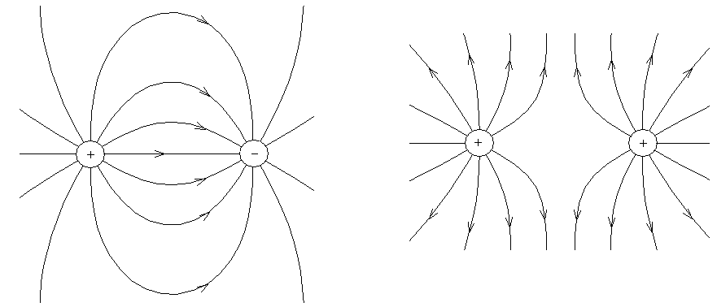

b. Field between two plates, one positive and one negative.
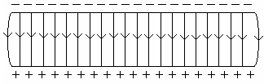

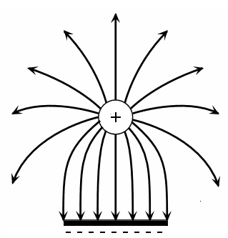
c. Field between a plate and a sphere where (i) both the same charge and (ii) different charges.

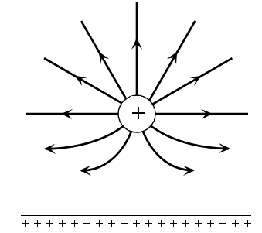

Questions:
- Draw an electric field around the following situation.  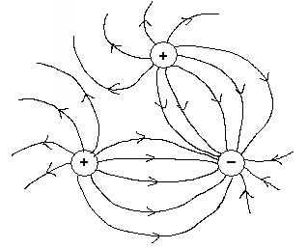 | - Identify the point charge in each of the following electric field diagrams.  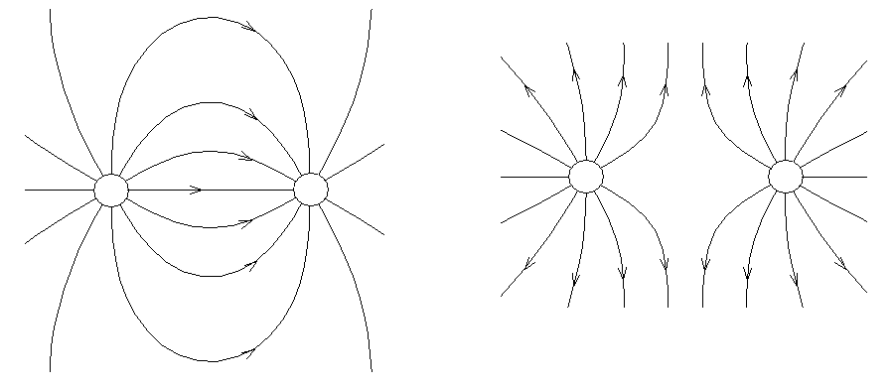  Positive on left Both positive  Negative on right
- Which is the positive plate in the following situation?  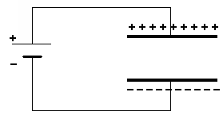 | - Explain why the field lines around a positive charge are close together near the charge but are further apart at a distance from the charge.  When close to the charge, the field is  stronger. This is indicated by the  closeness of the lines. Likewise, the  further away from the charge the weaker  the field.
Outcome 3:
Describe, explain and use electric fields between parallel plates and within uniform conductors, to explain the forces on charged particles—this will include applying the relationships:

Electric Fields in a Metal Conductor
Within metals, valance electrons surround positively charged metal ions. Therefore, within metal conductors, electrons are free to move if they experience an electric field. If you connect a power pack to the ends of a conductor, the electric field that is created causes a net flow of electrons. As the electric field direction is defined at the direction a positive charge would move, the electrons move in the opposite direction to the electric field.

Electric Field Strength (Electric Field Intensity)
The strength of an electric field (or electric field intensity) at any point in space is equal to the force per unit charge at that point.

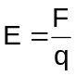 where: E = electric field strength (N C⁻¹)
F = force (N)
q = charge being moved (coulombs C)

Example: Complete with teacher assistance.
A point charge of 8.68 uC experiences a force of 5.44 x 10⁻³ N when it is placed into an electric field. Calculate the electric field strength at that point.

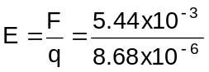
E = 626.7
E = 6.27 x 10² N

Questions:
- A force of 3.10 x 10⁻⁹ N east acts on a charge at point P which is in an electric field of strength 6.20 x 10⁻³ N C⁻¹ west.
- Calculate the magnitude of the charge.

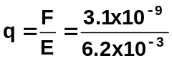
q = 5.00 x 10⁻⁷ q

- Determine the sign of the charge and explain why.
negative as the force is acting in the opposite direction to the electric field

- A charge of +5.00 uC is in an electric field of strength 1.60 x 10⁻³ N C⁻¹ north at point X. Calculate the force on the charge.

F = Eq
= 1.60 x 10⁻³ x 5.00 x 10⁻⁶
= 8.00 x 10⁻⁹ N north
(north as the charge is positive so it moves in the same direction as field)

NOTE: You will often be dealing with electrons and protons and the charge on an electron is -1.6 x 10⁻¹⁹ C while a charge on a proton is +1.6 x 10⁻¹⁹ C. This value is found in your data sheet.
Electric Field Strength Between Parallel Plates
We know as shown in the diagram to the right, that the field between two plates is uniform.

When a charged particle moves from one plate to the other through the electric field, the force from one plate increases while the force from the other plate decreases.
This way, the total force remains constant.

One way to set up a charge on each plate is shown below. Within this pair of plates an electric field is set up and work is done on a free moving electron to move it from one place to other.

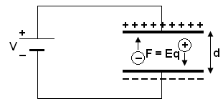

The work done = force x distance
W = Fs
but F = Eq so W = Eqd
now from stage 2 Electrical Fundamentals, we know that W = Vq so
Vq = Eqd “q” will cancel out so
V = Ed or more commonly
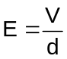 where: E = Electric field strength (V m⁻¹
V = voltage between plates (V)
d = distance between plates (m)

We can now combine the equations for electric fields and it can therefore be seen that the units for electric fields, N C⁻¹ and V m⁻¹ must be equivalent.

E = 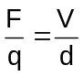

Example 1: Complete with teacher assistance.
Two charged parallel plates are placed 10.0 cm apart and a potential difference of 240 V between them.
- Determine the electric field strength between the plates.
E = 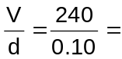2400
E = 2.40 x 10³ V m⁻¹
- If an electron is located halfway between the plates, what force would it experience?
F = Eq = 2.40 x 10³ x 1.6 x 10⁻¹⁹
F = 3.84 x 10⁻¹⁶ N
Example 2: Complete with teacher assistance.
An electric field intensity of 8.30 x 10⁴ V m⁻¹ is found between two charged parallel plates which are 6.50 mm apart.
- Calculate the potential difference across the plates.

V = Ed
= 8.30 x 10⁴ x 6.5 x 10⁻³
= 539.5
V = 5.40 x 10² V

- Calculate the gain in kinetic energy of an electron as it moves from the negative plate to the positive plate.

W = qV
= 1.6 x 10⁻¹⁹ x 539.5
= 8.632 x 10⁻¹⁷
W = 8.63 x 10⁻¹⁷ J

- Assuming that the electron was initially at rest on the plate, calculate its final velocity.

W = E_{k} = ½ mv²
8.632 x 10⁻¹⁷ = ½ x 9.11 x 10⁻³¹ x v²
v = 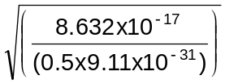 v = 13766119
v = 1.38 x 10⁷ m s⁻¹
Questions:
- A charge of -2.40 uC is in a electric field of strength 8.00 x 10⁻³ N C⁻¹ west at point X. Calculate the force on the charge.

q = -2.40 x 10⁻⁶ C F = Eq
E = 8.00 x 10⁻³ N C⁻¹ = 8.00 x 10⁻³ x 2.4 x 10⁻⁶
F = 1.92 x 10⁻⁸ N East
(as charge negative moves opposite direction to field)

- Two charged parallel plates are 10.2 cm apart. An electric field intensity of 3.50 x 10⁵ V m⁻¹ is set up between the plates.
- Calculate the potential difference between the plates.
V = Ed
= 3.50 x 10⁵ x 0.102
V = 3.57 x 10⁴ V

- Calculate the gain in kinetic energy of a proton as it moves from the negative plate to the positive plate.
W = Vq as work is equivalent to
= 3.57 x 10⁴ x 1.60 x 10⁻¹⁹ to kinetic energy,
W = 5.712 x 10⁻¹⁵ J E_{k} = 5.71 x 10⁻¹⁵ J

- Calculate the final velocity of the proton if it was initially at rest.

E_{k} = ½ mv²
5.712 x 10⁻¹⁵ = 0.5 x 1.67 x 10⁻²⁷ x v²
v = 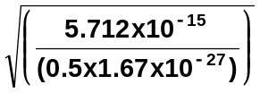 = 9.19 x 10¹² m s⁻¹
Outcome 4:
Apply the concept of force on a charged particle moving through a magnetic field—this will include applying the relationships:
Outcome 5:
Describe the factors which affect the magnitude and direction of the force on a charged particle moving through a magnetic field.

Force On A Charged Particle Moving In A Magnetic Field.

A free moving charged particle in a magnetic field will experience a force and be deflected. It
experiences a force as the movement of the charged particles creates its own magnetic field and this magnetic field interacts with the existing magnetic field producing a force which can change the direction of the charged particle.

The amount of deflection depends upon the magnitude of the force. The direction of the force can be determined by the right hand rule for positive charges.

For a positively charged particle at right angles to the field:

- fingers – point direction of field
- thumb – diction of velocity of positive charge (note: for a negatively charged particle the thumb points in the opposite direction to motion or use your left hand)
- palm – direction of force

NOTE: For negatively charged particles such as an electron, use your left hand.

Mathematical Relationship
The particle has a constant velocity through the field so v =
as ‘s’ is actually the length of the field, v = or = vt ……. equation ①
As the charge is moving, it must produce a current q = It or I = ……. equation ②
and from Electromagnetism, we know that the force on a current in a magnetic field is F = BI
now into F = BI, we substitute for ‘I’ (equation ②) and ‘l’ (equation ①) from above
F = B x x vt ‘t’ will cancel out so
F = Bqv sin θ where F = force on charge in newtons (N)
q = charge in coulombs (C)
v = velocity of charge in metres per second (m s⁻¹)
B = magnetic flux density in teslas (T)
sin θ = angle between directions of B and v.

It should be noted that when the charge is travelling parallel to the field, no electrometric force will be acting on it. There must be a component of the velocity cutting the field in order to produce a force.

While a charged particle remains in the field, the force, and therefore the acceleration, on the charged particle will be perpendicular to the motion. This results in the particle undergoing uniform circular motion. The magnetic force acting on a charged particle moving in the magnetic field can be seen to be a centripetal force (F_{c} = 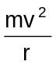) and therefore Bqv = .
Example: Complete with teacher assistance.
A beam of positively charged helium ions (He⁺) travelling at 6.00 x 10⁵ m s⁻¹ moves from east to west into a magnetic field of 2.50 x 10⁻² T which is directed vertically upwards. Find the magnitude and direction of the force acting on each ion.

v = 6.00 x 10⁵ m s⁻¹ F = Bvq
B = 2.50 x 10⁻² T = 1.60 x 10⁻¹⁹ x 6.00 x 10⁵ x 2.50 x 10⁻²
q = 1.60 x 10⁻¹⁹ C = 2.40 x 10⁻¹⁵ N
(has lost one electron
so has charge equal now for direction
to one electron)
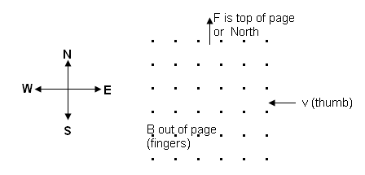
F = 2.40 x 10⁻¹⁵ N North

Path of a Charged Particle in a Magnetic Field
You know that particles experience a force equal to ‘Bqv’. This force can change the direction but not the velocity of the particle. As the force is always at right angles, the particle is force to follow a circular path. The force acting on the charge then becomes a centripetal force.
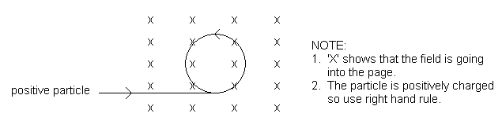The force on the particle depends upon the charge, velocity and magnetic field strength.

To determine the radius of curvature:
You know that F_{(field strength)} = Bqv and F_{(centripetal motion)} =
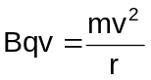
therefore: where r = radius in metres (m)
m = mass in kilograms (kg)
”v” cancels so v = velocity in metres per second (ms⁻¹)
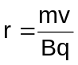 q = charge in coulombs (C)
B = magnetic flux density in teslas (T)

From the above relationship, we can see that for a given magnetic field strength, the circular path of a charged particle will depend on its velocity, charge and mass.

Example: Complete with teacher assistance.
A beam of electrons moves perpendicular to a magnetic field of intensity 6.00 x 10⁻⁵ T. If the electrons have a velocity of 1.20 x 10⁶ ms⁻¹, calculate:
- the force on each electron, (charge electron = 1.60 x 10⁻¹⁹ C)
- the radius of curvature of the path of the electrons. (mass electron = 9.11 x 10⁻³¹ kg)
- the direction the electrons will travel in the field shown.

a. F = Bvq
= 1.60 x 10⁻¹⁹ x 1.20 x 10⁶ x 6.00 x 10⁻⁵
= 1.15 x 10⁻¹⁷ N

b. 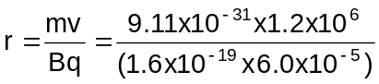
r = 0.114 m

c.
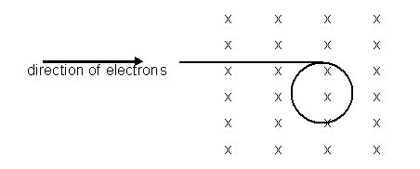

Example: Complete with teacher assistance.
A mass spectrometer is being used to determine the mass of a doubly ionized argon atom. The argon ions enter the magnetic field with a velocity of 1.71 x 10⁴ ms⁻¹ and follows a path of 9.40 cm radius. If the magnetic field strength is 5.50 x 10⁻² T,

  - what is the mass of the argon atom?
  - if the field is into the page, and the atom enters the field from the bottom of the page, draw the field and the path the atom will follow.

a. v = 1.71 x 10⁴ m s⁻¹ F_{c} = F_{e}
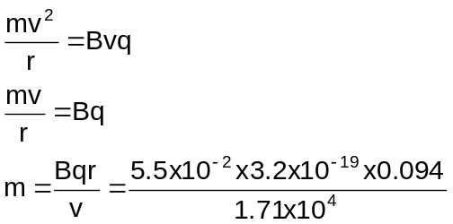r = 0.0940 m
B = 5.50 x 10⁻² T
q = 2 x 1.60 x 10⁻¹⁹
= 3.2 x 10⁻¹⁹ C
(as doubly ionised,
charge is twice
charge on electron)

m = 9.67 x 10⁻²⁶ kg
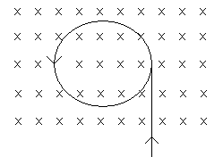
b.

positively charged particle
Outcome 6:

Explain and apply the concepts of electric and magnetic field in sequence or in combination –

this will include applying the relationships:

As you have seen electric and magnetic fields can be used in combination or in sequence to separate and identify moving charged particles. If both electric and magnetic fields exist, a moving charged particle will experience a force from each field. It should be noted that these fields do not have to be equal or in the same direction.

While both electric and magnetic fields apply a force to the moving charged particle, the force exerted by a magnetic field depends on the velocity of the particle, F = Bqv. This is not the case in an electric field, E = .

This different effects of electric and magnetic fields allow charged particles to be separated and identified.

Similarities:
As you can see from each equation, both fields are dependent on the magnitude of the field (E and B) and on the magnitude of the charge (q).

Differences:
Electric Field: The force is parallel to the field and independent of the velocity of the charged particle.
Magnetic Field: The force is perpendicular to the field and is proportional to the velocity of the charged particle.

Some Devices that use electric and/or magnetic fields

The Cathode Ray Oscilloscope (CRO)
The Cathode Ray Oscilloscope (CRO for short) is like a simple TV set and is used to display and measure electrical information.

A CRO has a large evacuated tube in which is a heater and electron gun, focusing and accelerating anodes, deflection plates both horizontal and vertical and a fluorescent screen that can display the electrons that hit it.
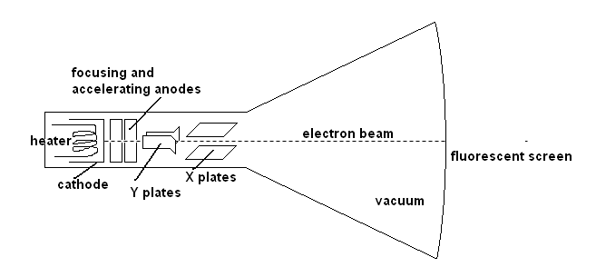
The Velocity Selector
As suggested by the name, this device separates charged particles on the basis of their velocities. An electric and magnetic field are set up perpendicular to each other. For specific velocities, the charged moving particles will experience equal and opposite forces as they move through the fields and will follow a straight path. For the forces to be equal, qvB = Eq and therefore v = . By adjusting the strength of E and B, charged particles with specific velocities can be selected.

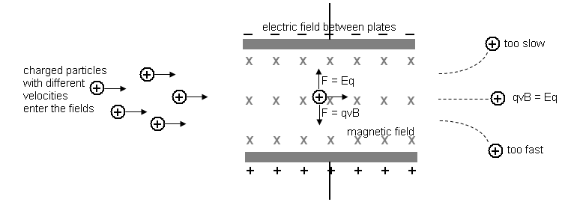

The Mass Spectrometer
A Mass Spectrometer can be used to measure both the masses and relative concentrations of both atoms and molecules. For this reason they can determine the masses of different isotopes of the same element, find and identify traces of contaminants or toxins and be involved in radioactive dating.

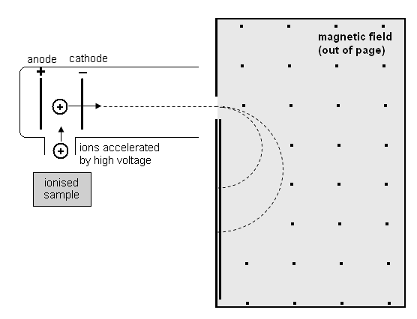
Initially, the substance must be vaporised and then ionised so charged particles are produced.
The ions are accelerated and then pass into the strong magnetic field perpendicular to the direction of the field.

Now we know that when charged particles enter a magnetic field, the radius of curvature is found by
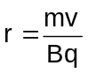
From the above relationship, we can see that for a given magnetic field strength, the circular path of a charged particle, and thus its radius, will depend on its velocity, charge and mass.

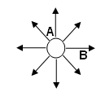
Revision Questions

  - Look at the diagram of an electric field around a point charge.
- Is the point charge positive or negative? positive
- Is the field stronger at A or B? A
- Explain your answer. The field is stronger at A as A is closer to the point charge. Alternatively, the field lines are closer together at A than at B so the field is stronger.

  - In one region the field lines are parallel and the same distance apart.
- What does this imply about the field? the field is the same strength and uniform

- Where could you find this field? between parallel plates.
  - Consider the following electric field with an electron placed in the middle. Draw an arrow on the electron to show the direction it will be moving.
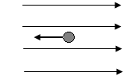

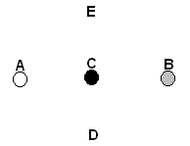
  - Two oppositely charged particles are placed at A and B as shown in the diagram below. A third charged particle (charge unknown) is placed exactly in the middle of the two charges at point C. To increase the force on the particle at C, in which direction should it move?
- towards A
- towards B
- towards A or B
- towards D
- towards E
- towards D or E answer: (iii)
Explain your choice. Moving towards either A or B will result in a stronger force as you are moving two charged particles closer together. The force will either be repulsion or attraction. Moving towards either D or E will move the particle further away from A or B so force will decrease.
  - An electron within a CRO experiences a force of 2.50 x 10⁻¹⁴ N towards the north. Determine the magnitude and direction of the electric field at that point.

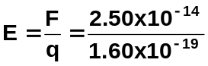 F = 2.50 x 10⁻¹⁴ N
q = 1.60 x 10⁻¹⁹ C

E = 1.56 x 10⁵ N C⁻¹

as it is an electron, it will move in the opposite direction to the field

E = 1.56 x 10⁵ N C⁻¹ South

  - A mass spectrometer accelerates a proton within an electric field of strength 3.00 x 10⁻⁵ N C⁻¹. Calculate the velocity of the proton.

F = Eq
= 3.00 x 10⁻⁵ x 1.6 x 10⁻¹⁹
F = 4.8 x 10⁻²⁴ N

F = ma
a = 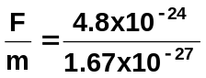

  - Two charged parallel plates 8.90 cm apart have an electric field of strength 3.00 x 10⁵ V m⁻¹ set up between them. If a proton was initially at rest, calculate the final velocity of the proton at it moves through the electric field.

V = Ed
= 3.00 x 10⁵ x 0.089
= 26700 V

W = Vq
= 26700 x 1.60 x 10⁻¹⁹
= 4.272 x 10⁻¹⁵ J

now work = kinetic energy gained so

E_{k} = ½ mv²
  - x 10⁻¹⁵ = ½ x 1.67 x 10⁻²⁷ x v²
v² = 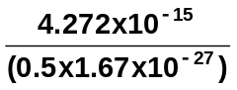
v² = 5.11616 x 10¹²
v = 2.26 x 10⁶ m s⁻¹

  - Below are some magnetic fields. A moving charged particle is shown entering the magnetic field. For each case, state the direction of the force acting on the charged particle.

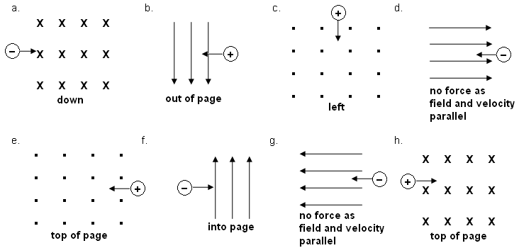
  - A particle with a charge of 4.80 x 10⁻¹⁹ C moves at 5.50 x 10⁵ m s⁻¹ from north to south into a magnetic field directed into the page. If the charge experiences a force of 3.50 x 10⁻¹³ N,
  - Determine the magnitude of the magnetic field.
  - Determine the direction of the movement of the charge within the field.

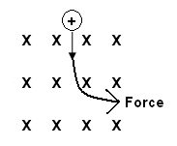
a. F = Bvq
3.50 x 10⁻¹² = B x 5.50 x 10⁵ x 4.80 x 10⁻¹⁹
B = 3.50 x 10⁻¹³ / (5.50 x 10⁵ x 4.80 x 10⁻¹⁹)
B = 1.33 T

b. as shown in the diagram, the force is towards the right or eastwards.

NOTE: The next question has the particle entering the field at an angle. While it is usual to deal with particles entering magnetic fields perpendicular, it doesn’t specifically say this in the outcome.
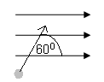
  - A charged particles of mass 2.55 x 10⁻²⁵ kg enters a magnetic field of 0.500 T at 60.0⁰ as shown in the diagram. If the particles has a charge of 6.40 x 10⁻¹⁹ C and is travelling at 125 m s⁻¹, calculate the force on the particle while in the field and the radius of curvature of the path it takes.

F = Bvq sin 60
= 0.500 x 125 x 6.40 x 10⁻¹⁹ x sin 60
F = 3.46 x 10⁻¹⁷ N

r = 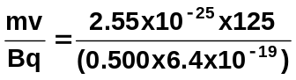

r = 9.96 x 10⁻⁵ m

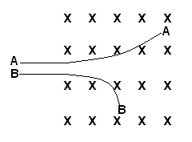
  - The diagram shows two charged particles ‘A’ and ‘B’ as they travel through a magnetic field at the same velocity. Determine the sign on each particle justifying your choice, then give one reason why each has a different radius of curvature.

Using the right hand rule, the particle that moves towards the top of the page is positive while the one that moves towards the bottom of the page is negative.

r = 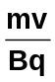 B and v are constant so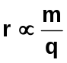
Now B is deflected more (smaller radius) so either its mass is less OR its charge is greater.
  - In a CRO, the electric plates are 10.0 mm apart and a potential difference of 5.00 x 10² V is placed across the plates. A magnetic field of 0.250 T is set up so that that a ray of electrons travel undeflected.
- Determine the strength of the electric field between the plates.
- Determine the force on each electron in the ray.
- Determine the speed of the ray of electrons as they pass through the plate.

- E = 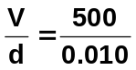
E = 50 000
E = 5.00 x 10⁴ V m⁻¹

- 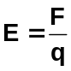
F = Eq
= 50 000 x 1.6 x 10⁻¹⁹
F = 8.00 x 10⁻¹⁵ N

- F = Bvq
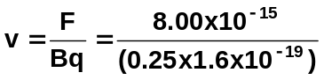
v = 2.00 x 10⁵ m s⁻¹
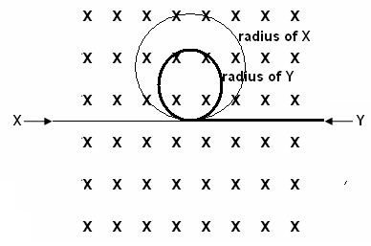

  - Two charged particles X and Y enter a magnetic field as shown on the diagram. X is positively charged while Y is negatively charged. Particle Y has a mass that is three times the mass of particle X. Particle Y is travelling at half the speed of particle X. Draw the path that each will follow showing an approximate relationship between the two radii.

Direction: Using right hand rule, both particles will move
towards the top of the page.

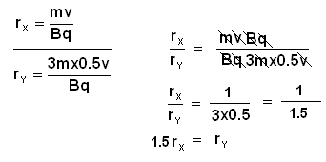
The calculations on the left
show that

r_{X} is 1.5 times as large as r_{Y}

OR r_{Y} is ⅔ r_{X}.

